Ideation Phase
Empathize & Discover

Empathy Map Canvas:
Understand the needs, frustrations, and behaviors of freelance professionals s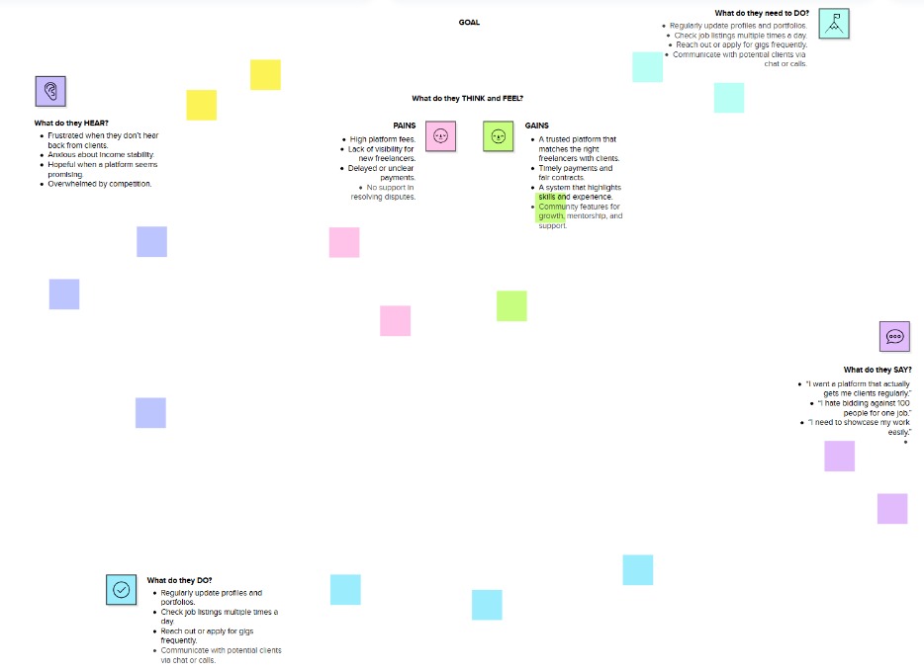

seeking consistent work through a platform like Freelance Finder.
Reference: https://www.mural.co/templates/empathy-map-canvas

